CAMPAIGN #1

Subject Line: Your Tips to Learn about Healthcare
From: Human Resources

Welcome to your tips on How to Speak Healthcare. Open enrollment can be complicated. Here at [YOUR COMPANY], we know how important the right healthcare plan can be for you and your family. Our goal is to help you understand the basics, if you need it, and give you support so you can make the right choice.

How to get started? Assess your life. This is personal. It’s about you and your family.

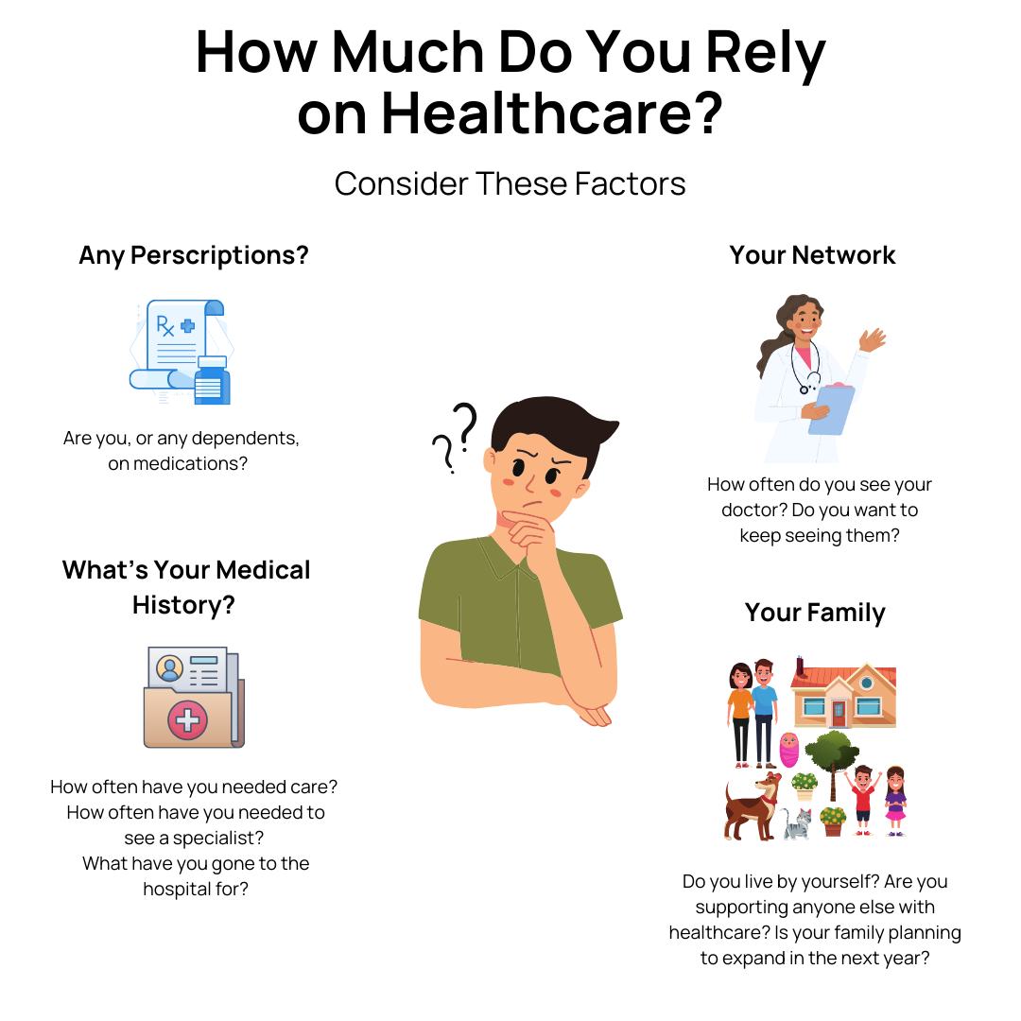

----

Our deadline to select an employer plan is ________.

Do you need more support? Contact [healthcare advocate or broker] or the Human Resources Department at ___________.

CAMPAIGN #2

Subject Line: Exploring Flexibility: HMOs vs PPOs
From: Human Resources

Our healthcare system is full of acronyms and what they mean for your situation.

Think of them as translating into varying levels of flexibility.

The more expensive the monthly payment, the more flexibility you have in choice of doctors and options.

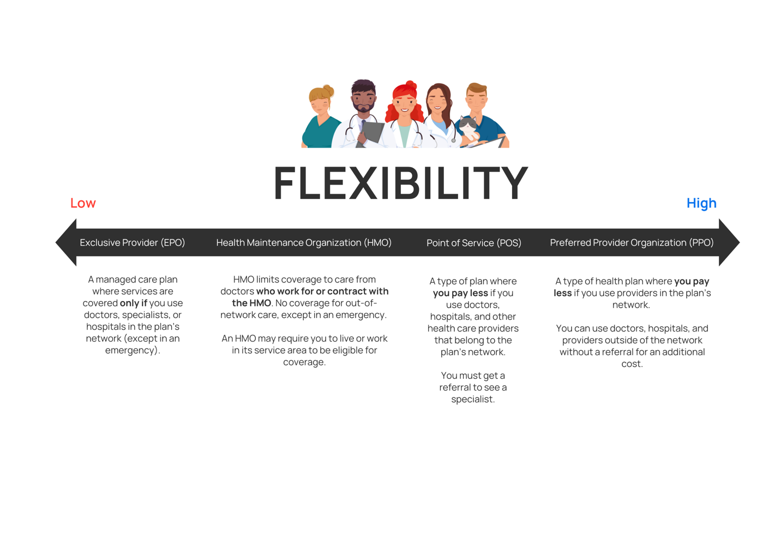
----

Our deadline to select an employer plan is ________.

Do you need more support? Contact [healthcare advocate or broker] or the Human Resources Department at ___________.

CAMPAIGN 3

Subject Line: What is In-Network or Out-of-Network?
From: Human Resources

If you’re in-network, you’ll pay the deductible, which are costs you can expect, but seeing out-of-network practitioners could mean costs you’re not expecting.

In-network: Providers or healthcare facilities that are in partnership with the insurance company.

Out-of-network: Providers or healthcare facilities that are not in partnership with the insurance company.

Ask yourself:

- When you go to the doctor, what network are they in?
- Is it important for you to stick with the same doctor next year?
- If you had to go to the hospital, where would you go?

We’ve all had that moment when we thought a provider was in-network only come to find out, they are not.

That’s why it’s important to research your provider, confirm they are (as well as their practice) is in-network with the plan you are choosing.

Tip: Call the plan and confirm your doctor and practice is in network. If there is any discrepancy and a representative says you are covered, but the plan says otherwise, request confirmation from the plan representative by email.

----

Our deadline to select an employer plan is ________.

Do you need more support? Contact [healthcare advocate or broker] or the Human Resources Department at ___________.

CAMPAIGN 4

Subject Line: What’s up with deductibles?
From: Human Resources

A deductible is what you will pay before insurance kicks in.

These lower monthly premium plans can be great, but it's recommended to have enough in the bank to cover your entire deductible (what you’ll pay upfront) the first half of next year, if the unexpected happens.

Is a high-deductible plan a good idea for me?

Ask Yourself:

- Are you single? Children are unpredictable and can be more prone to accidents.
- Do you have the funds for the deductible and out-of-pocket maximum currently in your back account? You’ll want to be prepared to pay.

----

Our deadline to select an employer plan is ________.

Do you need more support? Contact [healthcare advocate or broker] or the Human Resources Department at ___________.

CAMPAIGN 5

Subject Line: What Is a Health Savings Account (HSA)?
From: Human Resources

What are HSAs?

An HSA or Health Care Savings Account is a great option if you plan to make contributions over time. That’s where you will see the tax benefits.

Where and How Can I Use an HSA?

A Health Savings Account (HSA) lets you set aside money on a pre-tax basis to pay for ongoing medical services and treatments, like chiropractic care, acupuncture, or physical exams. Medical copays, deductibles, and coinsurance can also be covered under an HSA.

Ask Yourself

- Can you contribute to this account without using funds for the next several years? This is the best strategy when considering an HSA.

----

Our deadline to select an employer plan is ________.

Do you need more support? Contact [healthcare advocate or broker] or the Human Resources Department at ___________.

CAMPAIGN 6

Subject Line: Co-insurance vs. Co-pay
From: Human Resources

Co-insurance means you’ll pay a percentage until you reach your out-of-pocket maximum before insurance kicks in. These are lower monthly premiums plans.

Co-pay is what you pay every time you receive a service. Co-pays come with higher monthly premiums for more flexibility.

---

Our deadline to select an employer plan is ________.

Do you need more support? Contact [healthcare advocate or broker] or the Human Resources Department at ___________.

CAMPAIGN 6

Subject Line: How to Do Your Due Diligence with Healthcare
From: Human Resources

When selecting a plan, consider performing the following research.
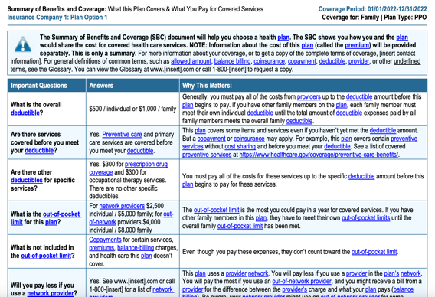
- Look at your plan’s detailed benefits coverage
- Does the in-network plan you’re considering have an emergency clause?
- If you’re on medications, search the formulary of the plan to see if it covers the prescriptions you’re on and research how much it will cost you to fill your medication.
  - If your medications are not covered, call them to see if they offer prior authorization for your medication.
- Make sure the preferred healthcare provider’s entire practice is in-network with the plan you are considering by calling the provider network and requesting coverage in writing.
- Search for your hospital’s name on the plan’s site.
- If you need help, contact your human resources department to help confirm coverage prior to making your selection.

---
Our deadline to select an employer plan is ________.

Do you need more support? Contact [healthcare advocate or broker] or the Human Resources Department at ___________.

CAMPAIGN 7

Subject Line: Have you selected a plan, yet?
From: Human Resources

Have you selected a plan, yet?

If you don’t select an employer plan, you will default to the plan you had last year. If it’s not available, you will not be covered.

Other options?

Check out healthcare.gov for exchange plans also known as the Affordable Care Act. Anyone can enroll in a state-covered health plan from November–January.

Our deadline to select an employer plan is ________.

Do you need more support? Contact [healthcare advocate or broker] or the Human Resources Department at ___________.

Thank you for your dedication to [YOUR COMPANY].

