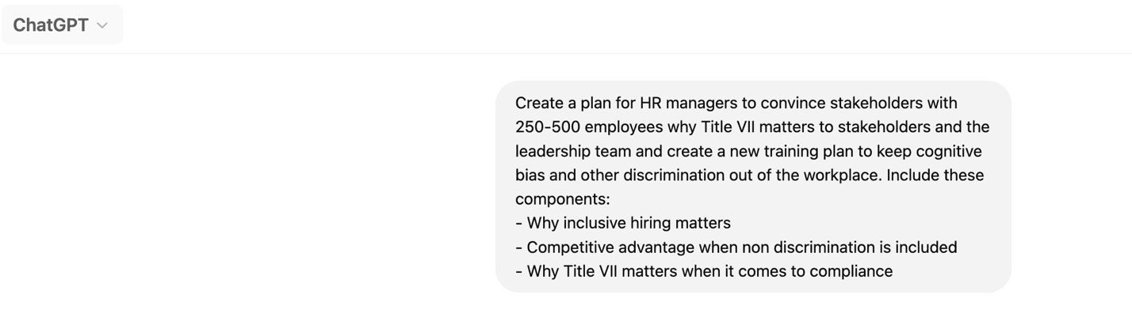
Here's a structured Plan Initiative Template for HR managers to present to stakeholders and leadership on why Title VII matters and how a new training plan can help prevent cognitive bias and workplace discrimination.

Title VII Compliance & Inclusive Workplace Initiative

Proposal for Leadership & Stakeholders

I. Executive Summary
Title VII of the Civil Rights Act of 1964 prohibits workplace discrimination based on race, color, religion, sex, or national origin. Ensuring compliance with Title VII is not just a legal requirement but a strategic advantage. This initiative outlines why inclusive hiring matters, the competitive benefits of non-discrimination, and the need for a comprehensive training plan to mitigate cognitive bias and workplace discrimination.

II. Business Case for Inclusive Hiring & Non-Discrimination

A. Why Inclusive Hiring Matters
- Access to a Larger Talent Pool – Attracts diverse, highly skilled candidates.
- Improves Innovation & Problem-Solving – Diverse teams outperform homogenous teams in creativity and decision-making.
- Enhances Workplace Culture & Retention – Employees in inclusive workplaces are more engaged and have higher job satisfaction.

B. Competitive Advantage of Non-Discrimination Policies
- Stronger Employer Brand & Reputation – Companies with inclusive policies attract top-tier talent.
- Higher Productivity & Collaboration – Inclusive teams drive performance, creativity, and adaptability.
- Market Growth & Customer Alignment – Diverse teams understand and serve diverse customer bases effectively.
- Reduced Legal & Financial Risks – Proactive training and policies prevent costly lawsuits and reputational damage.

III. Why Title VII Compliance is Critical
- Legal Obligations & Avoiding Litigation
  - Compliance with EEOC regulations protects against discrimination claims.
  - Penalties for non-compliance include fines, lawsuits, and reputational harm.
- Building a Safe & Inclusive Work Environment
  - Training programs can reduce implicit bias and prevent workplace discrimination.
  - A strong commitment to compliance fosters trust and employee satisfaction.

IV. Proposal: Implementation of a Title VII Training Plan

A. Training Objectives
- Increase Awareness of Title VII and anti-discrimination laws.
- Mitigate Unconscious Bias in hiring, promotions, and daily interactions.
- Foster Inclusive Leadership through education and accountability.
- Ensure Compliance & Best Practices for all employees, managers, and leadership.

B. Key Training Components
- Understanding Title VII & Workplace Discrimination – Legal framework and real-world case studies.
- Recognizing & Reducing Cognitive Bias – Practical strategies to minimize implicit bias.
- Inclusive Hiring & Promotion Practices – How to create fair and equitable opportunities.
- Reporting & Addressing Discrimination – Steps to ensure a safe reporting environment.
- Accountability & Leadership Responsibility – Ensuring buy-in from management.

C. Delivery Methods
- Interactive Workshops & Case Studies – Hands-on learning experiences.
- E-Learning Modules – Flexible, self-paced training.
- Managerial Coaching & Leadership Training – Equip leaders to set the standard.
- Ongoing Evaluations & Feedback Loops – Regular assessments to measure effectiveness.

V. Implementation Plan & Timeline
Phase | Action Steps | Timeline
Phase 1 | Secure leadership buy-in & allocate budget | Month 1
Phase 2 | Develop training content & resources | Month 2-3
Phase 3 | Pilot training program with a test group | Month 4
Phase 4 | Full company-wide rollout | Month 5-6
Phase 5 | Monitor, assess, and refine training effectiveness | Ongoing

VI. Key Metrics & Success Indicators
To measure the effectiveness of this initiative, we will track:
- Pre- & Post-Training Surveys – Employee awareness and attitude changes.
- HR Analytics – Changes in hiring, promotions, and retention rates.
- Incident Reports & Resolutions – Reduction in discrimination complaints.
- Employee Engagement Scores – Improvement in workplace inclusivity ratings.

VII. Call to Action & Next Steps
- Gain Leadership Approval & Commitment
- Assign Training Implementation Team
- Develop & Execute the Training Plan
- Monitor Progress & Adjust as Needed
By investing in this initiative, we ensure compliance with Title VII, foster an inclusive and high-performing workplace, and strengthen our company’s reputation and success in the industry.

